Data Sources:
- Census
- Ag Census (growth of agriculture, size of farms, etc.)
- Introduction of Ag Tech
- Railway
- Interstate
- Schools
- Grocery stores
- Hospitals
- Crime

Kendra Spahr - Academic Services Librarian
Shawn Hutchinson - K-State GIS contact

Tech Stack:
Client - Vue
Server - Node
RelationalDB - Postgres

Client UI
Will show a map of Kansas with county lines and symbols in each county and throughout the state to represent statistics and certain events.
Able to select between decades, the map changes per decade.
Show important events/changes that occurred in each county in each decade.
Clicking on a county will bring up a small window with specific information about the county.
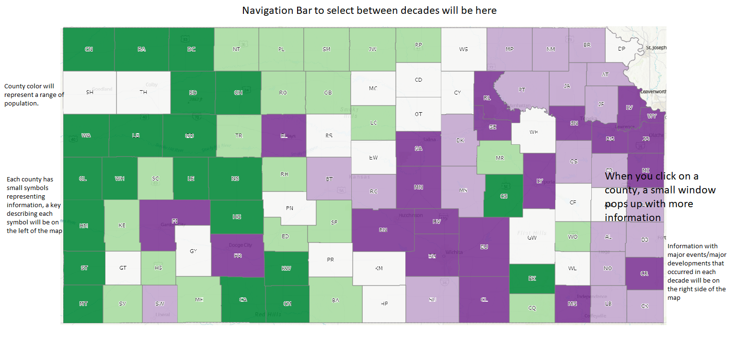

General Database Diagram
https://drive.google.com/file/d/1tP-lui3PWYvlSFaHywTBGyK4rmhHLUG8/view?usp=sharing

Technical Requirements
- Should be deployed as a docker image with configurable:
- Specifiable port for a reverse proxy
- CAS protocol parameters
- Database connection string
- Should support reverse-proxied https
- Should authenticate using the CAS protocol
- Should utilize a PostgreSQL database
- Should utilize postGIS for GIS data integration
- Should utilize ArcGIS map API
- Must conform to ADA requirements
- Should use Vue for front-end development
- Should use Node for back-end development

Functional Requirements
- The Rural Data Visualization system will display this data visualization on both desktop and mobile devices in a useable way that is accessible to all students and schools
- The display must conform to all accessibility requirements, including but not limited to:
  - Proper labeling of all images and graphics
  - Compatibility with screen readers
  - Specified and logical tab order for controls
  - Visual indications that are clear even for colorblindness
  - Drag-and-drop elements of sufficient size for low dexterity
- Students can download a png of their view, whether it be a state or county view, with certain information types selected. They can also save a gif of their view as the time period of the information changes
State View of Kansas
- The main page will show a map of Kansas with the country boundaries with a heatmap showing the population density of the counties. This is the default view that will always be shown.
- Show allow students to select and deselect any combination of the other sources of relevant information, but only one of types 3-8 (see below) at a time
- Will have an “Update” button that will redraw the map with the new selected filters, and this button will only be selectable if the filters have changed
- Must have a key that interprets how each information type is being shown
  - When “Update” is clicked, the key is updated to include interpretations of selected information types and exclude deselected information types
- Will have a sliding bar at the top to represent the time frame by decade, so students can select a decade and even slide to see how the data changes over time without needing to select the “Update” button
  - Will show a title above the navigation bar for the era of Kansas History the year selected is in
- If a selected form of information isn’t available during the time period, a pop-up will list any of the information types that are not shown on the main map
- The other information types that students can select are as follows:
- Railroads
  - Will display the location of the operative railroads on the map at that time
- Highways
  - Will display the location of the operative highways on the map at that time
- Grocery Stores
  - Will show the number of grocery stores by county
- Hospitals
  - Will show the number of hospitals by county
- Schools
  - Will show the number of schools by county
- Crime
  - Will show the number of violations by county
- Size of farms
  - Will show the range of farm size by county
- Size of households
  - Will show the range of household size by county
County View
- Students can select a county which will open up a map of that county and the previous information types on the side (selected filters stay selected)
- Students can select and deselect new information types and click the “Update” button to view those changes only on the county map. Those selection changes will not be reflected on the state view when the students exit the county view
- The information types 3-8 will now display by town if that information is available

